Lab Assignment 2-1 Exploring File Systems-Editing Text Files Linux+ and LPIC-1
Instructions: In this assignment you should follow each step but paste screen facsimiles of your screen results only on steps 8, 27, and 36.

- At the command prompt, type pwd, press Enter, and ensure that your home directory is displayed, showing that you are in your home folder. At the command prompt, type vi sample1 and press Enter to open the vi editor and create a new text file called sample1. Notice that this name appears at the bottom of the screen along with the indication that it is a new file.

- At the command prompt, type My letter and press Enter. Why was nothing displayed on the screen? To switch from command mode to insert mode so you can type text, press i. Notice that the word Insert appears at the bottom of the screen. Next, type My letter and notice that this text is displayed on the screen.

- Press Esc. Did the cursor move? Yes
What mode are you in now? command mode.
Press ← two times until the cursor is under the last t in letter.
Press the x key. What happened? It insert the x between 2 letter ‘t’: My letxter.
Next, type i to enter insert mode, then type the letter “h.” Was the letter “h” inserted before or after the cursor? before

- Press Esc to switch back to command mode and then move your cursor to the end of the line. Next, type the letter “o” to open a line underneath the current line and enter insert mode.

- Type the following: It might look like I am doing nothing, but at the cellular level I can assure you that I am quite busy. And to a typical cell, it may seem like they are doing all the work! Notice that the line wraps to the next line partway through the sentence. Though displayed over two lines on the screen, this sentence is treated as one continuous line of text in vi. Press Esc to return to command mode, and then press ↑. Where does the cursor move? At a letter ‘r’ at end of the first line.

Use the cursor keys to navigate to the letter “l” at the beginning of the word “level,” and then press the i key to enter insert mode. Press the Enter key while in insert mode. Next, press Esc to return to command mode, and then press ↑. Where does the cursor move? At the beginning of second line.

- Type dd three times to delete all lines in the file.

- Type i to enter insert mode, and then type: Hi there, I hope this day finds you well. and press Enter. Press Enter again. Type: Unfortunately, we were not able to make it to your dining and press Enter. Type: room this year while vacationing in Algonquin Park – I and press Enter. Type: especially wished to see the model of the Highland Inn and press Enter. Type: and the train station in the dining room. and press Enter. Press Enter again. Type: I have been reading on the history of Algonquin Park but and press Enter. Type: nowhere could I find a description of where the Highland and press Enter. Type: Inn was originally located on Cache Lake and press Enter. Press Enter again. Type: If it is no trouble, could you kindly let me know such that and press Enter. Type: I need not wait until next year when I visit your lodge? and press Enter. Press Enter again. Type: Regards, and press Enter. Type: Mackenzie Elizabeth and press Enter. You should now have the sample letter used in this chapter on your screen. It should resemble the letter in Figure 3-3.

- Enter.Esc to switch to command mode. Next press the Shift and ; keys simultaneously to open the : prompt at the bottom of the screen. The Shift and ; keys typed simultaneously are called last line mode. At this prompt, type w and press Enter to save the changes you have made to the file. What is displayed at the bottom of the file when you are finished? Display Sample1 in your assignment submission.

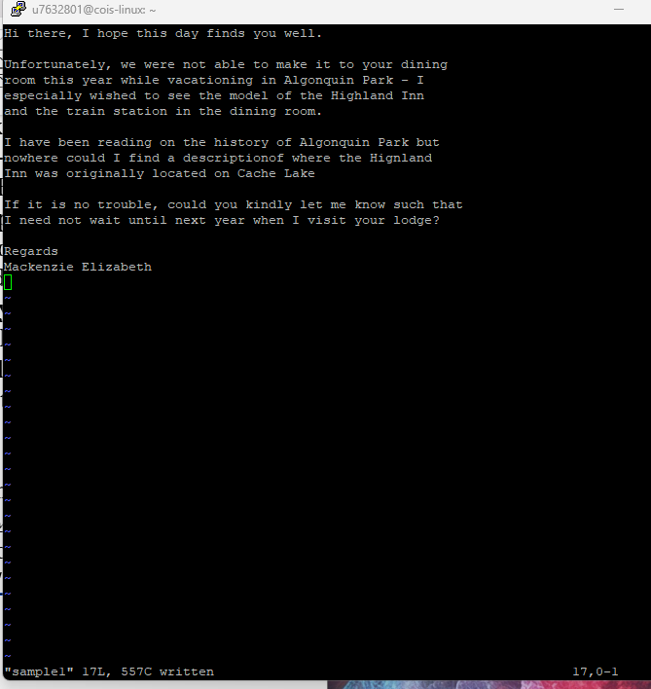

- Enter Last line mode to open the : prompt at the bottom of the screen again, type q, and then press Enter to exit the vi editor

- At the command prompt, type ls and press Enter to view the contents of your current directory. Notice that there is now a file called sample1 listed.

- Next, type file sample1 and press Enter. What type of file is sample1? ASCII text
At the command prompt, type cat sample1 and press Enter.

- At the command prompt, type vi sample1 and press Enter to open the letter again in the vi editor. What is displayed at the bottom of the screen? “sample1” 17L, 557C
How does this compare with Step 9? “sample1” 17L 557C written

- Use the cursor keys to navigate to the bottom of the document. Enter last line mode keys to open the : prompt at the bottom of the screen again, type !date and press Enter. The current system date and time appear at the bottom of the screen. As indicated, press Enter to return to the document.

- Enter last line mode again to open the : prompt at the bottom of the screen again, type r !date and press Enter. What happened and why?

This is a way to insert the current date and time into your document without leaving vi or opening a separate text editor. It's a convenient feature for adding timestamps to your files.

- Use the cursor keys to position your cursor on the line in the document that displays the current date and time, and type yy to copy it to the buffer in memory. Next, use the cursor keys to position your cursor on the first line in the document, and type P (capitalized) to paste the contents of the memory buffer above your current line. Does the original line remain at the bottom of the document? Yes

- Use the cursor keys to position your cursor on the line at the end of the document that displays the current date and time, and type dd to delete it.

- Use the cursor keys to position your cursor on the t in the word “there” on the second line of the file that reads Hi there, I hope this day finds you well., and press dw to delete the word. Next, type i to enter insert mode, type the word Bob, and then press Esc to switch back to command mode.

- Enter last line mode to open the : prompt at the bottom of the screen again, type w sample2 and press Enter. What happened and why?
Because "sample2" does not exist, vi will attempt to create a new file with that name and save the contents of the current file into it.

- Press i to enter insert mode, and type the word test. Next, press Esc to switch to command mode. Enter last line mode keys to open the : prompt at the bottom of the screen again, type q, and press Enter to quit the vi editor. Were you able to quit? Why not?
No. When you press "i" to enter insert mode, you're still in the process of editing the file. After typing "test" and pressing "Esc" to return to command mode, you need to save your changes before quitting.

- Enter last line mode keys to open the : prompt at the bottom of the screen again, type q! , and press Enter to quit the vi editor and discard any changes since the last save.

- At the command prompt, type ls and press Enter to view the contents of your current directory. Notice it now includes a file called sample2, which was created in Step 18. Type diff sample1 sample2 and press Enter to view the difference in content between the two files you created.

- At the command prompt, type vi sample2 and press Enter to open the letter again in the vi editor.

- Use the cursor keys to position your cursor on the line that reads Hi Bob, I hope this day finds you well.

- Enter last line mode to open the : prompt at the bottom of the screen, type s/Bob/Barb/g, and press Enter to change all occurrences of “Bob” to “Barb” on the current line.

- Enter last line mode to open the : prompt at the bottom of the screen again, type 1,$ s/to/TO/g, and press Enter to change all occurrences of the word “to” to “TO” for the entire file.
- Press the u key to undo the last function performed. What happened and why?

- Enter last line mode to open the : prompt at the bottom of the screen again, type wq, and press Enter to save your document and quit the vi editor. Display Sample2 in your assignment submission.
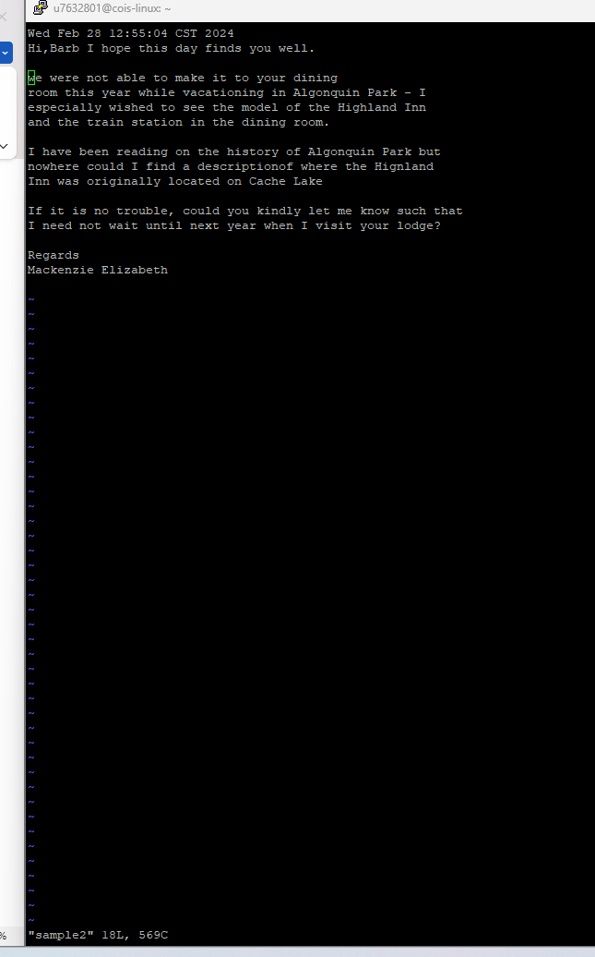

- At the command prompt, type vi sample3 and press Enter to open a new file called sample3 in the vi editor. Type i to enter insert mode. Next, type P.S. How were the flies this year? Press the Esc key when finished.

- Enter last line mode to open the : prompt at the bottom of the screen, type wq, and press Enter to save your document and quit the vi editor.

- At the command prompt, type vi sample1, press Enter to open the file sample1 again, and use the cursor keys to position your cursor on the line that reads “Mackenzie Elizabeth.”

- Enter last line mode to open the : prompt at the bottom of the screen again, type r sample3, and press Enter to insert the contents of the file sample3 below your current line.

- Enter last line mode keys to open the : prompt at the bottom of the screen, type s/flies/ flies and bears/g and press Enter. What happened and why?
This command performs a substitution in the current line (since no range is specified) searching for the string "flies" and replacing it with "flies and bears". The 'g' at the end stands for "global" and tells vi to replace all occurrences of "flies" on the current line.

- Enter last line mode keys to open the : prompt at the bottom of the screen again, type set number, and press Enter to turn on line numbering.

- Enter last line mode to open the : prompt at the bottom of the screen again, type set nonumber, and press Enter to turn off line numbering.

- Enter last line mode to open the : prompt at the bottom of the screen again, type set all and press Enter to view all vi parameters. Press Enter to advance through the list, and press q when finished to return to the vi editor.

- Enter last line mode keys to open the : prompt at the bottom of the screen again, type wq, and press Enter to save your document and quit the vi editor. Display Sample1 (again) in your assignment submission.

